|  |
| --- |
| **Audit Name: Production Support (PBM/Specialty)**  **Audit Number: 21303**  **Prepared By: Seun Mafi**  **Date Completed: 08/24/2021** |

|  |  |
| --- | --- |
| Control & Sample Information | |
| Control | C.2 – Lower Level Product Testing |
| Sample Number | N/A |
| Supporting Documentation Received From | Ganesh Gouthamchand, IT Director (Change Council) |
| Received Date | 08/21/2021 |
| Purpose of the Test | The purpose of this test is to ensure that lower level product testing for application changes completed on Hive Center and AppLens is quality reviewed by Cognizant in accordance with CVSH change management standards. |
| Source Files | [AppLens and HiveCenter PROD Changes June 2020 through May 2021](https://cvshealth.auditboardapp.com/download?file_id=117254&name=AppLens%20and%20HiveCenter%20PROD%20Changes%20June%202020%20through%20May%202021%20(5).xlsx)  [Integration List](https://cvshealth.auditboardapp.com/download?file_id=120642&name=Integration%20List.xlsx)  [CVS PBM Prod Support CR Tracker](https://cvshealth.auditboardapp.com/download?file_id=120641&name=CVS%20PBM%20Prod%20Support_CR%20Tracker.xlsx) |

**Attribute A: The testing was properly documented within ServiceNow.**

In gaining an understanding of the change management environment, IA received from Ganesh Gouthamchand (IT Director (Change Council) on 08/21/2021, a full list of all CVS applications which are integrated with HIveCenter. IA observed that ServiceNow application is used to trigger automation workflow and also creating change request tickets for events. *See evidence below:*

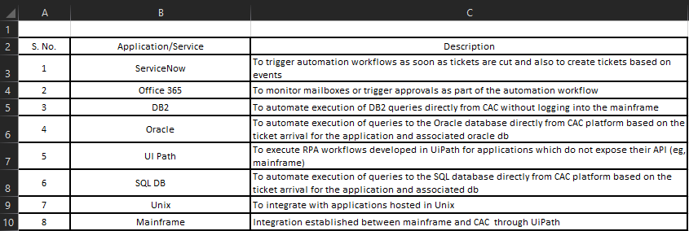

Following process walkthroughs with the business, IA observed that lower level product testing for HiveCenter and AppLens is performed by the Enterprise Quality Assurance Team. IA reviewed the AppLens and HiveCenter Production Changes document provided by Ganesh Gouthamchand on 08/21/2021 which covers the period June 2020 through May 2021 to ensure that application change testing are properly documented within ServiceNow. Each production change is assigned a unique change number and assigned what type of change it is, either Normal or emergency change. For all changes documented, there was a planned start date and end date respectively, a requester and assignee as well as the environment to which the change is assigned to. IA noted that for all the changes documented within the timeframe, they all have been closed out.

*See evidence below:*

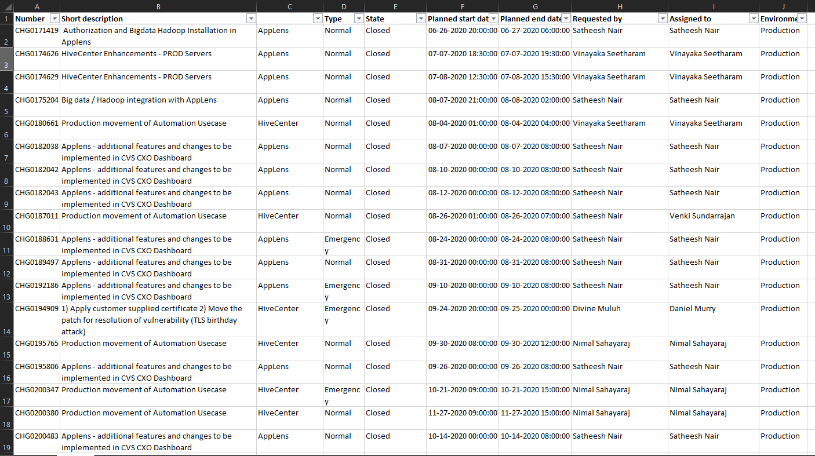

IA gained assurance that testing was properly documented within scope period June 2020 through May 2021.

Attribute satisfied.

**Attribute B: A peer review and/or manager review was performed, and evidence was retained**

IA reviewed the CVS PBM Prod Support Change Request Tracker document provided by Ganesh Gouthamchand (IT Director (Change Council) on 08/21/2021, *see* [CVS PBM Prod Support CR Tracker](https://cvshealth.auditboardapp.com/download?file_id=120641&name=CVS%20PBM%20Prod%20Support_CR%20Tracker.xlsx). IA noted that for every change request inputted, the following parameters were documented:

1. Application name
2. Tower
3. Requested by, request date and proposed retirement date
4. CR Category
5. SOW Scope
6. How long the review period took
7. Approval status and comments among other fields.

IA observed that a manager review was conducted and evidence to support approval status with comments was equally documented. *See evidence below:*

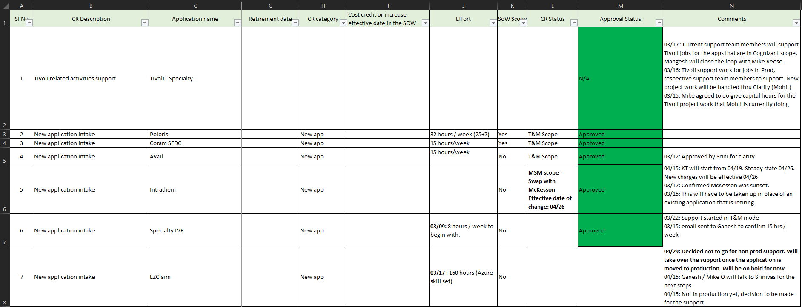

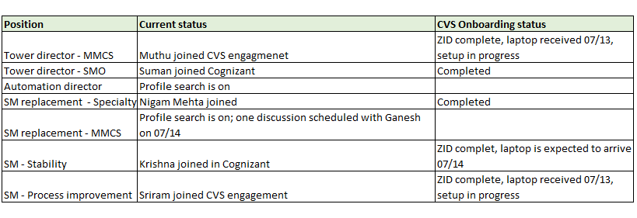

Based on the supporting evidences provided above, IA determined that a manager review was performed, and evidenced were retained.

Attribute satisfied.

**Attribute C: If any issues are identified, the proper documentation and remediation is performed by Cognizant and communicated to CVS.**

In the CVS PBM Prod Support Change Request Tracker document provided by Ganesh Gouthamchand, IA noted that some of the change request documented contained a rejection status and an “on hold” status with each change request assigned further clarification as to why the Change request was rejected or classified “on hold” respectively. A proposed time for when a new review would be carried out was also documented as well as remediation plan in the form of further discussion with management which ultimately led to approval status was included.

*See evidence below:*

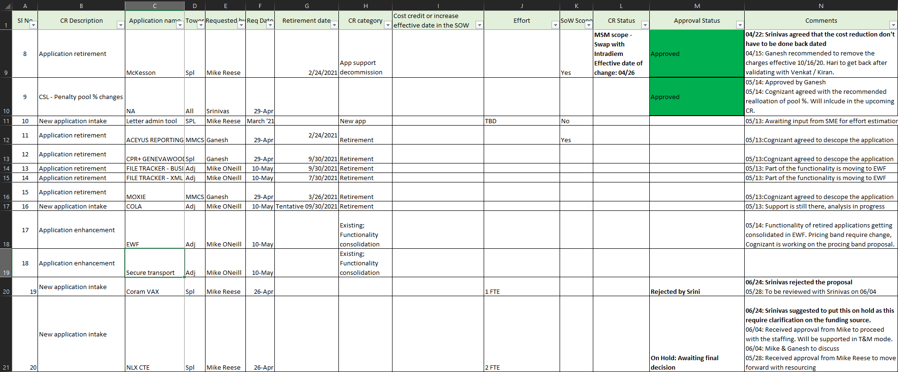

For example, SI #20 – New Application Intake, an initial request date of 04/26 was recorded, and after discussions with Mike Reese (Pharmancy Systems Support, Director, IT Systems) and Ganesh Gouthamchand (IT Director, change council), an approval notice to move forward with resourcing was received from Mike on 05/28. IA gained assurance that issues identified, and remediation is performed by Cognizant and communicated to CVS. Attribute satisfied.

**Conclusion:**

IA concludes from reviewing the CVS PBM Prod Support CR Tracker, AppLens and HiveCenter Production Changes, and Integration list documents that lower-level product testing for application changes completed is quality reviewed. Control appears to be operating effectively.